# Section 1. Project management

Car online management system is a system which is designed for such owners and users who are interested in cars. This system keeps track of each and every single detail of cars. Our team members have followed each and every process or steps to ensure effective development and deployment of the online car showroom management system. Our team has worked on each and every detail very closely and had meetings on each and every stage to meet the requirements of the projects. Following are the steps or process that we follow while developing this project:

**Planning:** It is the first stage of any project management system where we plan to guide about the development of the system starting from process defining project milestones to ending the process at the platform to be used. Planning of projects is the most important step as it helps to identify work management, cost estimation, and risk identification which further helps to develop effective and efficient projects.

**Analyzing:** It is the process where we understand the objectives, goals, and scopes of a system. Project analyzing involves evaluating project scope, timeline and budget analysis, risk assessment and quality checking. It further includes stakeholder’s satisfaction. It checks and analyzes whether the team members' performance is cooperative or not. It was conducted by a system analyst. The requirement that we gathered for the analysis of the project include functional and non-functional requirements and other specific features.

**Design:** Here in this step, we focus on creating a user-friendly website for the owners or users who are interested in cars. Firstly, using Balsamiq we create a wireframe and then we design mockups through Adobe Dreamweaver.  Here we use [draw.io](http://draw.io/) and lucid charts to create a detailed diagram to see how the data is processed on the system. In the design phase we had a presentation and meetings with stakeholders to meet the requirement for the final deliverable of the project.

**Implementation:** In this phase, all the planning and designs are implemented to develop an effective and efficient project. Firstly, our developers code for the project to develop an online car management system. Here, they use HTML, CSS, JS, and PHP. We use GitHub to communicate with each other or to share important codes and documents. While implementing the plan we had taken care about the security so that the password wouldn’t be hashed and stored directly in the database.

**Testing:** This is one of the most important phases in developing the system. In this phase, all the functions are tested, and bugs and errors are fixed. This process ensures the quality, reliability, and performance of a project. Here, we conduct different testing methods such as unit testing, system testing, integration testing, and functional testing, etc.

**Deployment:** Deployment of a project refers to the process of making a project available for use. Once the system or project passes all the steps and is ready to deploy it is uploaded to the host which will make the system available and accessible for the users on the internet. For the hosting process, we have registered domain names and set up all the security measures.

# Section 3.1 Objective of system testing

The main objectives of the online car showroom management system are that it provides a provision to customers or owners or users to buy or book cars online who are interested in cars. A web-based information system for online car management is currently being developed as part of the system or project. After completion of the integration phase, plans are further scheduled to white box testing and black box testing.

**Black box testing:**

It is a software testing method which focuses on the testing of a software without having knowledge about internal works and focuses on the validation of its behavior based on the specified inputs and expected outputs. Here, test scenarios are based on functional specifications, use cases and requirements documentation. It behaves as expected from an end-user perspective.

**White box testing:**

 It is also known as clear-box, glass-box or structural testing which is a testing method which focuses on the internal examination of the logical and structural work. In white-box testing, the tester has the knowledge of the internal work of the system which includes the code, data structure, flowchart, and algorithm. The goal of white box testing is that all the paths are tested in each and every step to ensure an error free website and ensure the code is tested at least once throughout the process or system.

# 3.2 Test Summary

|  |  |
| --- | --- |
| Project Name | Lorbek Cars Showroom |
| System Name | Lorbek Online System |
| Version Number | * 1. First Release |

Table 1: Test Summary

# 3.3 Rational for Test Result

|  |  |
| --- | --- |
| Pass | The Function is working correctly. |
| Fail | The function is not working correctly. |
| Partial Pass | The Function have error while running. |

Table 2: Test Results

# 3.4 Testing the Operating System Platform

|  |  |  |  |  |  |  |
| --- | --- | --- | --- | --- | --- | --- |
| Test ID | Test Function | Test date | Tester | Test result | Comments | Figure |
| TC001 | Mac | 30/01/2024 | Salina | Pass | Working Correctly |  |
| TC002 | Windows | 30/01/2024 | Salina | Pass | Working Correctly |  |
| TC003 | Android | 30/01/2024 | Salina | Pass | Working Correctly |  |
| TC004 | Iphone | 30/01/2024 | Salina | Pass | Working Correctly |  |

**Mac**

**Windows**

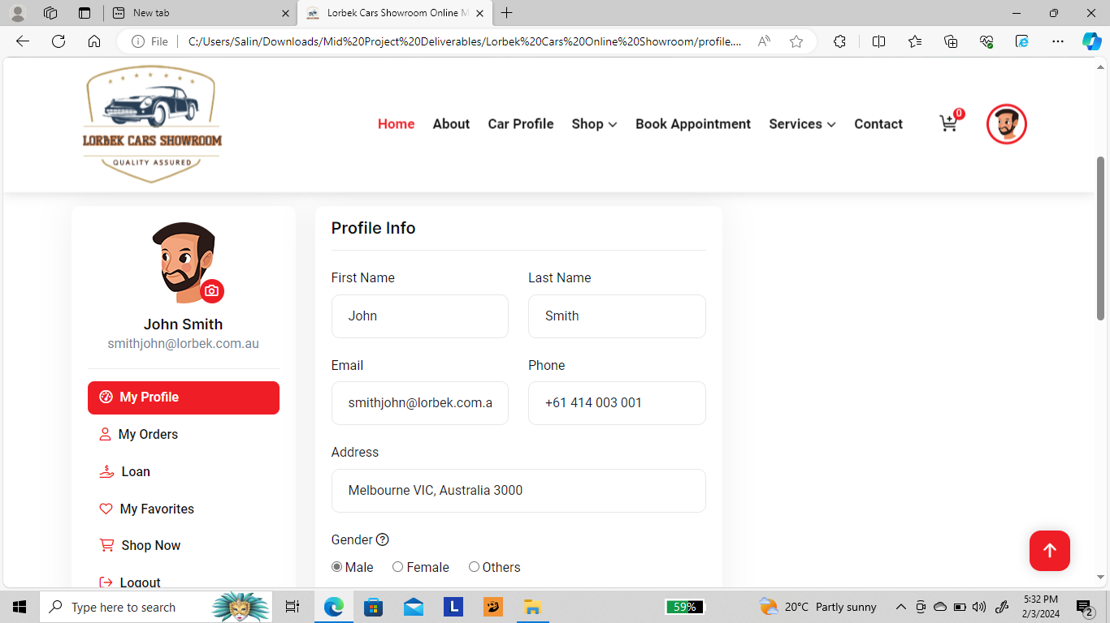

**Iphone**

**Android**

